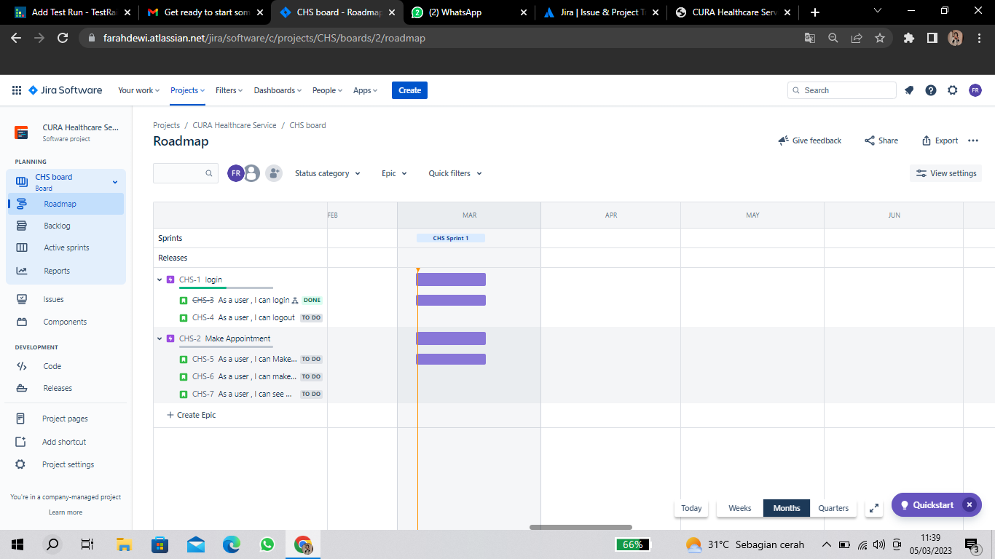

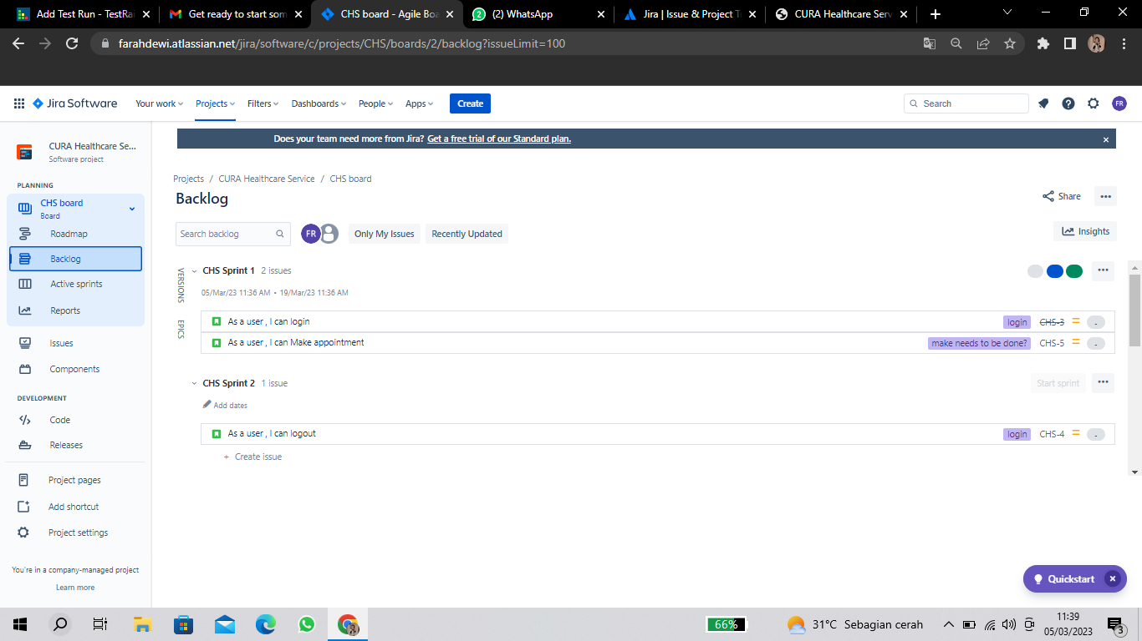

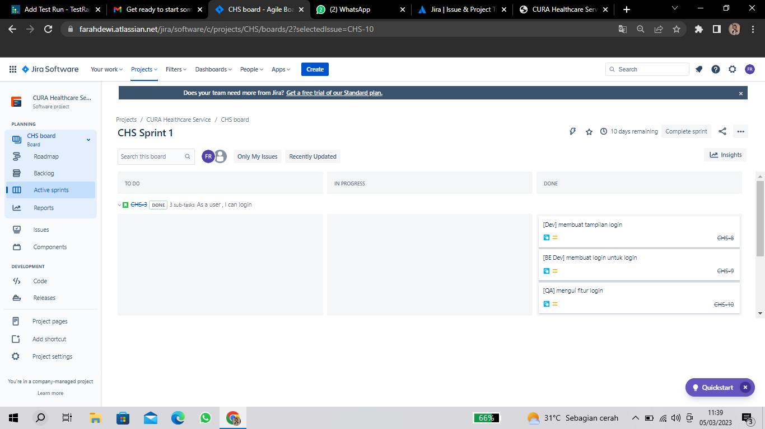

**https://docs.google.com/document/d/1J9qB2VzB8RtTC9wu_UDiAdH0Cac_zkZzkaJRNsoM9HM/edit?usp=sharing**